**Full Stack Development with MERN**

**Frontend Development Report**

|  |  |
| --- | --- |
| Date |  |
| Team ID |  |
| Project Name | FitFlex :Your Personal Fitness Companion |
| Maximum Marks |  |

**Project Title:** SB Fitzzz..

Date: [Date of Report]

Prepared by: Sakshi Subhash Mulik

**Objective**

The objective of this report is to document the frontend development progress and key aspects of the user interface (UI) implementation for the **SB Fitzz** project. This project is focused on providing a dynamic and engaging fitness platform with various exercise categories, workout routines, and features to help users maintain a healthy lifestyle.

**Technologies Used**

* **Frontend Framework:** React.js
* **State Management:** [Redux/Context API, if applicable]
* **UI Framework/Libraries:** **Material-UI**, **Bootstrap**, or **Tailwind CSS** (for responsive design and UI components)
* **API Libraries:** Axios (for fetching exercise data, videos, etc.)

**Project Structure**

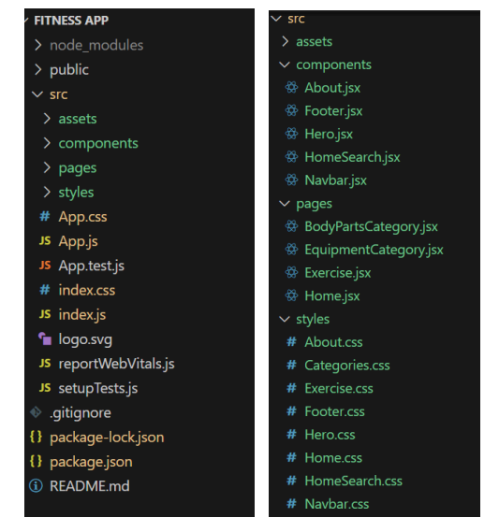

**Routing**

* **/home:** Landing page showcasing the app's features, introduction to fitness, and popular exercises.
* **/category/:id:** A category page displaying exercises under different fitness categories (e.g., Strength Training, Yoga, Cardio).
* **/exercise/:id**: Detailed exercise page with instructions, images, and related videos.
* **/profile:** User profile management page, where users can save their favourite exercises, track their progress, etc. **State Management (If Applicable)**

**State management is achieved using [Redux/Context API].**

* **Fetching available Equipment list & Body parts list**

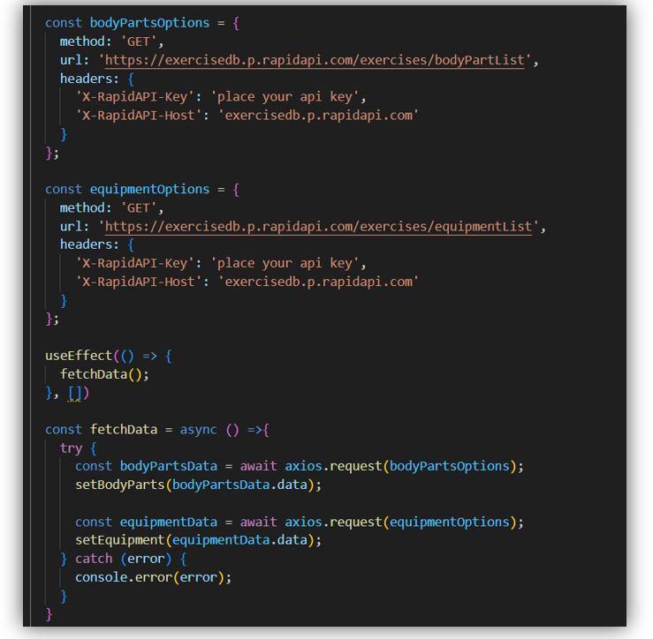

**Fetching exercises under particular category**

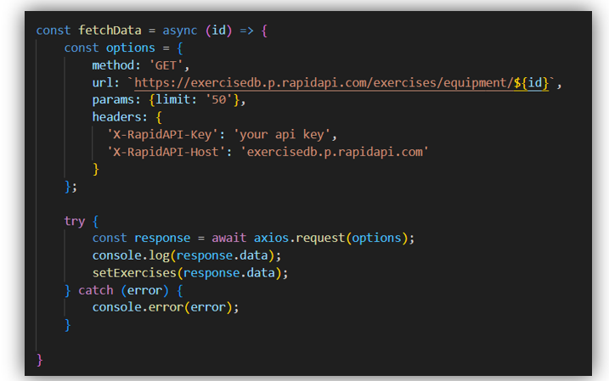

* **Fetching Exercise details**

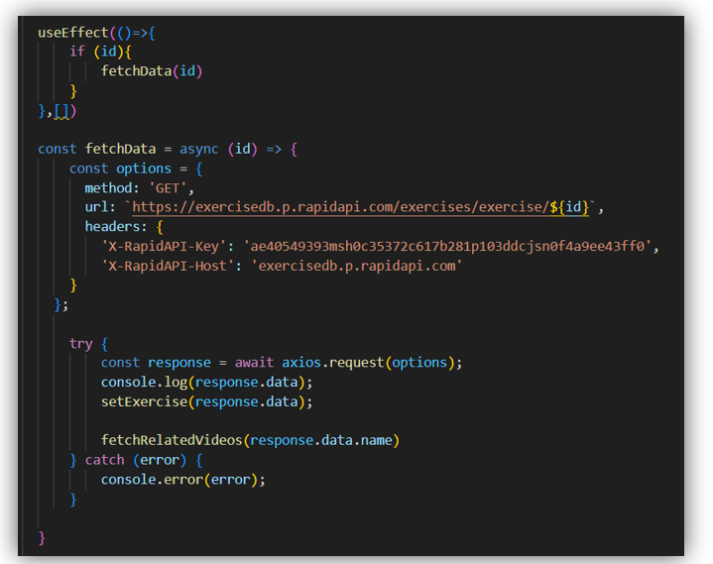

**Fetching related videos from YouTube**

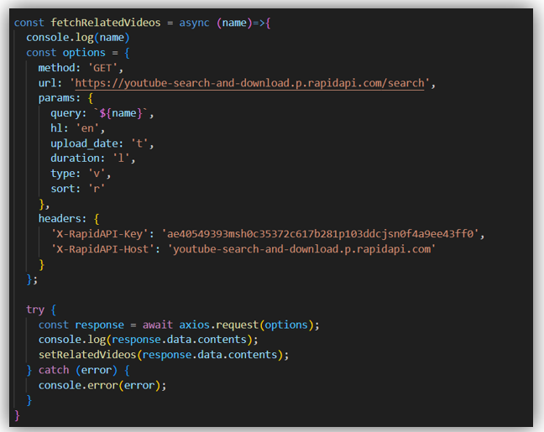

**User Interface (UI) Design**

* **Hero component**

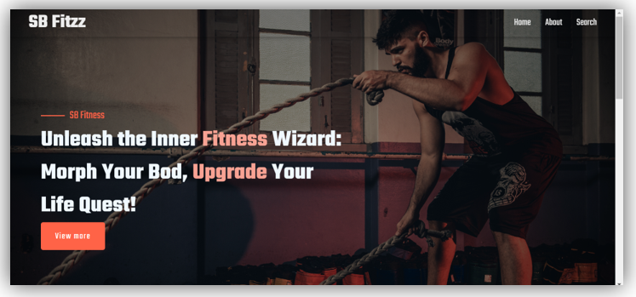

* **About**

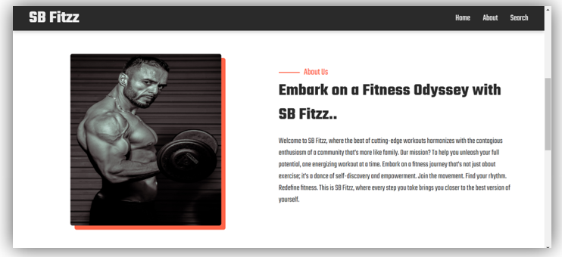

* **Search**

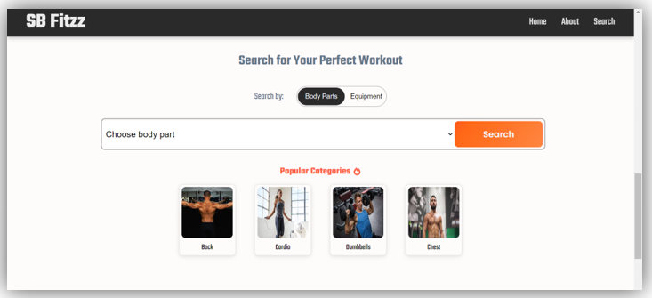

* **Category page**

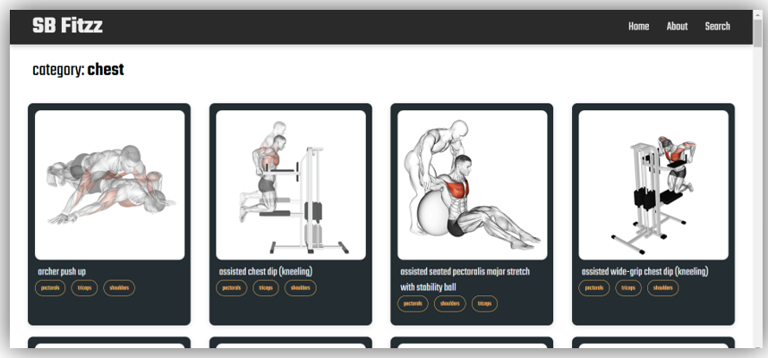

* **Exercise page**

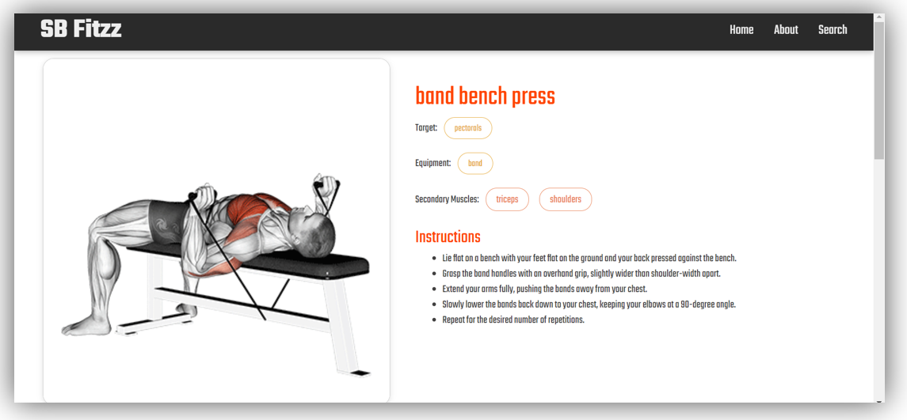

**Third-Party Integrations (If any)**

* **Axios**: Used for making HTTP requests to external fitness APIs to fetch exercise data, video tutorials, and other relevant information.
* **YouTube API**: Integrated to fetch related exercise videos to enhance the user experience with video instructions.
* **React Router**: Used for routing between different pages of the application.
* **Material-UI/Bootstrap/Tailwind CSS**: Used for creating a responsive and aesthetically pleasing UI.